Bioc 404 NTC, January 16th 2006

Sedimentation equilibrium

Using this method, you end up with an equilibrium distribution of a protein (or nucleic acid) in solution. This equilibrium is due to the fact that diffusion counteracts the centripetal force.

At 10 000 rpm, the equilibrium condition looks as follows:
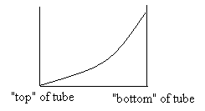

Note that at 40 000 rpm, you would essentially end up with all particles at the bottom of your tube.

Once we reach equilibrium, the free energy change ΔG to more any particle from a position r₁ to a position r₂ in our tube is 0 (since we’re at equilibrium). So,

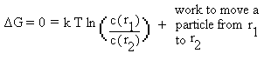
Since the work is Force x Distance, the work to move a particle from r₁ to r₂ is the integral of the work function from r₁ to r₂. In other words:
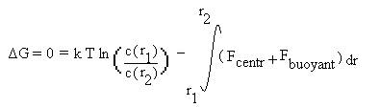
Replacing F_{centr} and F_{buoyant} by the equations we’ve seen before,
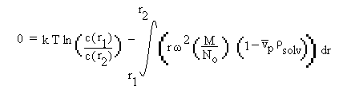

Rearranging gives:
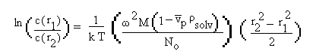

and finally:
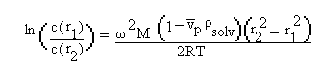

All of this applies when we’re dealing with a single type of particle.

Now we can make the following plot (after we’ve reached equilibrium):

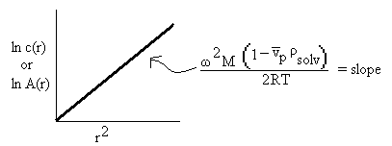

The advantage of this method is that the diffusion coefficient (D) is not required to find the molecular weight (M) of a macromolecule.

Preparative ultracentrifugation to determine M or s data

The problem in a preparative centrifuge cell (apart from the fact that you cannot continuously monitor what’s going on) is that, because of the cell’s shape, the lines of force go into the walls of the tube. This causes a few problems:
- Increase in local density of MM’s at the walls of the cell or local aggregation.
- Convection and other “bad” means of sedimentation
- Simply put, bad data.

A partial solution to this problem is to use density gradients (eg. sucrose). This avoids the local ‘density inversion’ that leads to convection resulting from the accumulation of MM’s near the walls.
In addition, the gradient is more stable such that manipulations do not disrupt it (therefore, you can determine the distribution of MM’s post-centrifugation).

Now, remember that the speed of a particle’s movement is determined by the following formula:
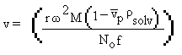
We’ve seen before that the frictional coefficient (f) is proportional to solvent viscosity (η_{solv}). So we know have three terms (r, ρ_{solv}, and η_{solv}) that vary with position in a gradient. This is not good for our analysis.

The solution is to create an isokinetic gradient such that

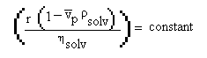
This way, the velocity is constant anywhere in the gradient and, at any point, the velocity of a particle is proportional to the sedimentation coefficient at the top of the gradient
(v_{part i} = s_{part i} at top of gradient).

The experiment
- On top of a gradient (sucrose or other), overlay a thin sample of buffer containing multiple species i of varying molecular weight (usually some standards are in there), but of similar v_{p}. In other words, proteins or DNA, but not both.
- Centrifuge long enough so that all particles migrate significantly but none reach the bottom of the tube.
- Remove the cell, fractionate and determine the distribution of macromolecules.

The results
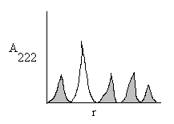
The shaded peaks represent standards of known molecular weights and the unshaded peak is an unknown.

Migration distance = v_{o} * time α S_{for species i} at top of gradient

This method is only good to 20-30% accuracy, so it gives an approximation, but is not as good as with an analytical centrifuge.
An example using MRP (macrophage cytoskeletal regulating protein)

In this experiment, an analytical centrifuge was used to conduct both sedimentation velocity and sedimentation equilibrium ultracentrifugation.

The sedimentation equilibrium plot of ln(c) vs. r² gave a straight line. Thus, we’re dealing with a single type of particle (i.e. a monomer or a stable complex).

A curved line would have indicated that we’re dealing with a reversible, concentration dependent association. Then, a simple curve fit can be done by computers to get association constants.

Sedimentation velocity was the conducted and s was determined. From this, we can get s_{20,w} (MRP).

Now that we know both M and s_{20,w} , we can calculate D_{20,w}.

Using the equation f = kT/D, we can get the frictional coefficient (f).

With all this information, it becomes possible to estimate the value of the Perrin factor (F) using approximations about δ_{w}.

